The Quandary of the Modeled Example: Featured Power

In the previous section during the discussion of volition, I mentioned a quandary best solved by a modeled example. I am resuming the discussion here. A model is something that serves as a real-time example which embodies the necessities of a perceived need. I need to understand what a true animae is; I can sit here and talk for hundreds, perhaps thousands, of pages about what I think is necessary or what I believe these concepts are. But what I think and what I believe are irrelevant in the larger sense. It is the result that is most important, not how the result is gleaned, or what was done to glean it. Ethical discussions aside, a level of control must be provided to contain the scope of data. These controls are reduced to one simple parameter: that a machine will function and experience growth without the aid of human intervention. Considering the state of technology in the world today, how can this be possible? An independent machine, in order to function, must use some sort of portable power. The source of portable power is the battery. But let’s reduce the argument further. The machine requires energy which just so happens to be in the form of a portable power source such as the battery. It is the energy which provides the life force of the machine, and the energy is in the form of electricity. The scientists of the day stop there and relegate themselves to using batteries with wall-mounted recharger units to satisfy this condition. Certainly, there is no human intervention, right? Wrong. A wall-mounted system requires extra hardware and software and cannot anticipate our tests of survival mechanisms, the strongest driving force of volition or, in this discussion, choice. When a life form can expire because of the lack of food, it behaves quite differently than one which has a steady, reliable source. It is the difference between an adult trying to survive on its own and an infant feeding at its mother’s breast. The infant knows food will always be there and without a threat to the food supply, will do little if anything to expand itself beyond the confines of its environment. And animae are not equivalent to infants; infants have the capacity to grow and directly access their environment in the context of comfort with their parents who they trust explicitly. A machine does not or should not have such luxuries if we are to understand what and why it is.
The food supply should be carefully regulated and be a composite function of the machine, not a consequence of its operation. This puts the idea of batteries straight out. The machine will always have a full stomach and a plethora of energy, and if it gets hungry, it can initiate a search for the wall source and plug in. Some believe this is a feature of choice but it is merely an uninspired routine written by clever engineers. The feature of choice will not be explored until the machine understands that its survival depends on its energy source. It must have only enough to run itself and not be able to plug in. This parameter sets up a causality loop, a dependency of food retrieval and survival. As with humans, we have a diet particular to our species established by a long sequence of evolutional events. For the machine, this must be no different. Power must be considered as a feature of its operation with a range of “tastes”. The feature is designed as a consequence of source. There cannot be one source of power but a range of efficiencies depending on the transmission frequencies. Let me provide an example.
A favored model in this text is the cat, specifically a house cat. A house cat has its meals depending on the whim of its owner and adjusts its tastes accordingly. During the course of a day, a meal of dry food is provided. At a specific time, say at 1700 hours, a wet meal is given. If this routine is continuous and without interruption, the cat will come to anticipate the wet meals at the specified time. It will then begin to choose what type of wet meals it likes best. This sometimes causes dismay in its owner but establishes the point. In time, the cat will hone its taste to a unique meal which might be fish, beef, or chicken. My personal research has determined my cat likes chicken in gravy and performs tricks once the meal appears at the time it is expected. This evidence points that choice can be modulated by environmental derivatives.
We can do the same with a machine. Basing our analysis on the tools we have gleaned from our ethology study of the cat, we can set up a system of parameters for the machine’s operation. To establish the best parameters for the best data pool, let’s design the machine in context with featured power. Consider Figure 6.
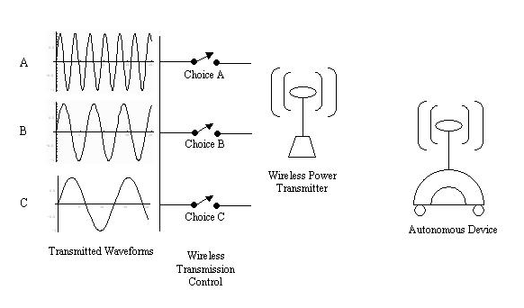Figure 6: Featured Power
Here is a simple diagram of how we should set up our apparatus. We begin by establishing the parameter that three different types of waveforms can be transmitted via the wireless device, noted as A, B, and C. Each waveform has approximately the same amplitude but a different frequency which can be received in the domain of the receiving apparatus, the autonomous device. The circuit of the autonomous device can utilize each waveform but at different efficiencies. The design of the transmitter allows each waveform to send a packet of power upon each oscillation and each of these packets are equal in magnitude. Remember from our earlier discussion of the wireless power device that the E and M vectors are equal with a different H as represented by the frequency of the composite form. H gives us the varying efficiency of the form which directly effects the amount of power arriving at the receiver in a given constant of time. The receiver uses a scaled down version of the transmitter; the spiral coil in the receiver is smaller by a factor of four. This allows for size constraints and demonstrates the logarithmic difference in the total system. This number becomes important when we discuss feedback.
Let’s consider the type of machine we want to test. There are many types of robots available to the consumer these days and many types of platforms. The experiment at hand requires a platform that has sufficient space for specialty onboard components and room for additional modules as we learn more about what we want to accomplish. When we did the ethology study of the animal, we considered the environment in which it roams. We should do the same for the machine. It is best at the beginning to have rooms large enough for the machine to navigate and where we can set IR transmitter/receiver packages along the walls. I wouldn’t recommend extending the roaming area to stairs or to rooms larger than 15m² for sake of simplicity and ease of project expense. It is okay to use more than one room and recommend to do so as long as the connection between the rooms is a flat surface. The transmitter can be received at a distance of 50 meters with its present design and can use wall outlets to power it; it shouldn’t be necessary to construct a larger device if the environmental dimensions are controlled.
Give careful consideration to the means of locomotion of the machine. Be aware that it is crucial to the success of the experiment that the machine run at all times. Certain locomotive components are easier to maintain for long hours of use than others. I wouldn’t recommend machines with legs; they consume more power and if some components are weak by the nature of their design, the machine will be more prone to breaking down. Initiating repair cycles is okay as long as they don’t have to be implemented too often. Remember, we want the machine to operate as free from human intervention as possible. For all these reasons, I recommend a wheeled machine as pictured in Figure 7.
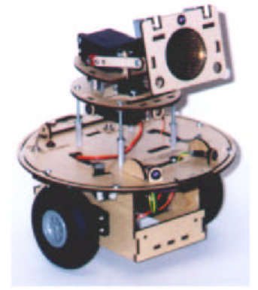
Figure 7: A Typical Wheeled Robot Platform
This platform is large enough to contain the initial modules and allows expansion for others as we become more familiar with the conditions of our experiment. We cannot know all the variables we are anticipating so it is best to expect there will be more than we figure. The plate at the center of the robot is about 35cm in diameter and the total device weighs about 5kg. It can hold what we need to get started. Two servo motors and a steering mechanism, MC68HC11 Motorola central processing unit, 2048K of memory, PIC buffers, and 8092K of external memory. This should suffice to get us started. Now that we have the physical components ready (we can change them as they become necessary) let’s consider the power levels in the three waveforms to get it energized.
There are three modes of operation for our device. Sleep, average, and high power represented by C, B, and A respectively. At a given time of day, the machine receives a level of power necessary for its operation. We have rated the machine’s base operation at 12VDC with a current draw of 0.125A at any given time. We must consider the quantity in time when the energy will be transmitted. The consumed power of the device is p/s = e x i or 1.5 watts per second. The transmitter/receiver package in Figure 6 will satisfy this constraint as we will be transmitting power at a pulse quantity relative to the earth’s energy transmission pulse which is 1μs. So, we will have approximately 1 million pulses arrive at the receiver in a second (inv 1 x 10⁻⁶). The power transmitted will remain constant between the transmitter and receiver and will not build upon itself unless the power is shunted. So, during any period of time, the amount of energy received will be very close to constant. In other words, unless the power is used by a loaded circuit, it will not transmit more than the quantity we have set for it by the frequency of the wave. The power quantity is only for the base components of the system—the microprocessing unit and its supplementals, the motors and steering. The power of each waveform is:
Waveform A: 15 volts x 1.0 amperes = 12 watts.
Waveform B: 15 volts x 0.500 amperes = 6 watts.
Waveform C: 15 volts x 0.200 amperes = 2.4 watts.
We will expect to send a higher quantity of power than that what is anticipated to be used. This way we can account for loss in the transmission, changes in the earth’s pulse duration by meteorological phenomena, and reduce the possibility of feedback on the signal. Feedback is a significant factor in this apparatus but is not necessary to be considered at this time. I will cover the aspects of feedback later. The quantity of waveform C is power just above the device’s operational requirements. When C is active in the transmitter, the machine only has the ability to move about slowly, there is not enough power to do more than cursory motions about the room. It is best to consider waveform C as a “sleep” mode. It cannot power its higher functions such as IR sensors, wireless communication, or outward communication such as a vocal transceiver. The IR function is only available when waveform B is transmitted and the optional equipment such as the vocal transceiver is only available when waveform A is transmitted. I will cover software implication of the higher systems later in this section. To get a reign on what we are putting into the machine, we need to categorize the onboard components in hierarchal form.
Base 1) Microprocessing and supplemental circuits.
Mid 2) Servos and motor control; IR communication.
High 3) Vocal transceiver, vision, higher computational systems (program writer).
The “Base” is considered the subsistence forms, the “Mid” the locomotive elements, and the “High” the higher functions which at this point will remain variable as we learn more from our experiment. The machine can function as a sycophant with the lower two functions present, but cannot add to its repertoire of programming without the writer active which is only available at the higher level. These are the necessary conditions to test our hypothesis. The research question at this point is, can the machine choose whether or not it wants to learn?
How can we accomplish this subtlety? Since it cannot be directly observed, suffice it to say for now that the machine cannot perform higher functions unless waveform A is available to be received. Still, it has the ability to observe the environment and can affect the outcome of its place in it. If it can maintain waveform B long enough, it has the ability to send a wireless signal to the wireless transmission control module and initiate the switch for each of the three waveforms. This provides an avenue for it to bring online its “High” functions such as the program writer. But if it is “content” with only having its lower functions, it will not initiate the communication at the module and stay at the power levels we have provided for it.
We begin by only providing waveform C to the machine during the course of a day. At specified times, say at 900, 1100, 1300, 1500, and 1700 we tell the switch to transmit waveform B for a duration of twenty minutes. The software will activate at the higher power levels and initiate the IR and full locomotion systems to come online. During its operation for each of the twenty minutes, the system will log its experience, rate its successes and failures according to a routine we have described for it. We will program one of the IR transmitters along the wall with a line of code that will show the pathway of the higher circuits and how to initiate them. They will not activate them, but simply show the machine that they are there. At this point we are at the level of the original Grey Walter experiments in the early 1950s when he hypothesized Elsie was able to make a choice. It is important to discuss the experiment now before we continue.

